CST 415 – Lecture 8
Wilsonville, Fall 2017

DHCP - Dynamic Host Conﬁguration Protocol
CNP 5.2.2, Pg. 156; ICN 7.9, Pg. 176
https://en.wikipedia.org/wiki/Dynamic_Host_Configuration_Protocol

Used to manage a pool of IP addresses for a sub-net
Each host is assigned an address dynamically, when it needs one

The protocol is abbreviated “DORA”: Discover, Offer, Request, Acknowledge

When a client needs an IP address, it sends a DHCPDISCOVER request over UDP
The request’s source IP is 0.0.0.0 and destination IP is 255.255.255.255 (broadcast)
This allows the client to discover the DHCP server
Note: the discover includes the client’s LAN address, so the DHCP server can contact it

DHCP servers pick up the packet, allocates and address and sends a DHCPOFFER
The offer’s destination IP is 255.255.255.255 (broadcast) so the client receives it
The offer includes: Allocated IP Address, Subnet Mask, Default Router, DNS Server

The client chooses a DHCP server’s offer and sends a DHCPREQUEST for an address
The DHCP server sends a DHCPACK to the client, optionally including lease duration
When a lease expires, the address is returned to the pool

DHCP is a protocol at which layer?
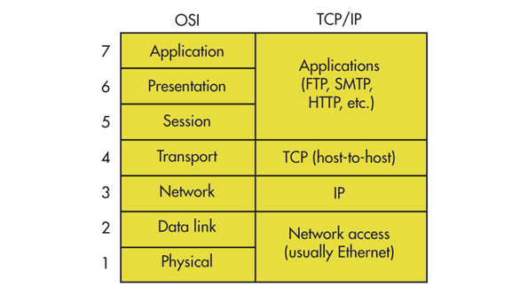

ICMP – Internet Control Message Protocol
CNP 5.2.2, Pg. 151-157; ICN 7.10, Pg. 178-181
https://en.wikipedia.org/wiki/Internet_Control_Message_Protocol

Informs the sender of a packet of a problem during transmission and/or routing

ICMP messages are carried as the payload of IP packets, with protocol = 1

The header includes three required fields; additional fields depend on msg type
Type – ICMP message type
Code – ICMP message sub-type (depends on type)
Checksum – Calculated for ICMP header

Some interesting messages types…
Type | Code | Description
0 – Echo Reply | 0 | Ping response
3 – Destination Unreachable | 0 | Destination network unreachable
3 – Destination Unreachable | 1 | Destination host unreachable
3 – Destination Unreachable | 2 | Destination protocol unreachable
3 – Destination Unreachable | 3 | Destination port unreachable
5 – Redirect Message | 0 | Redirect Datagram for the Network
5 – Redirect Message | 1 | Redirect Datagram for the Host
8 – Echo Request | 0 | Ping request
11 – Time Exceeded | 0 | TTL expired in transit
13 – Timestamp | 0 | Timestamp with current time on originating router
14 – Timestamp Reply | 0 | Response with current time on receiving router

Type 0 and Type 8 are used by the ping utility to determine if a destination is reachable

Type 3 messages are used to communicate errors to a client, e.g.
Router cannot reach the destination network
Destination host is not responding to router
Protocol is not supported on the destination host
Port is not open on destination host
etc…

Type 5 redirection is used to optimize routing (see next page)

Type 11 indicates that the TTL count has reached zero
This happens when a packet has passed through too many routers (indicates a loop!)

Type 13 and Type 14 are used to synchronize time on routers

There are many more types/sub-types; many have been deprecated over the years
Example router optimization using ICMP Type 5 Redirection message:

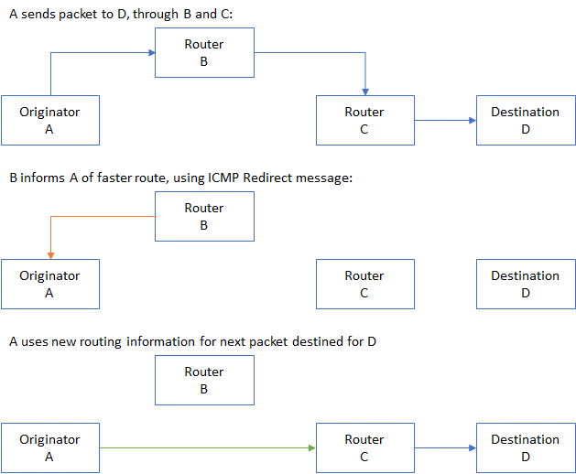

Nice, right?
Danger! Redirection can allow nefarious actors to initiate “man-in-the-middle” attacks
How does this look?

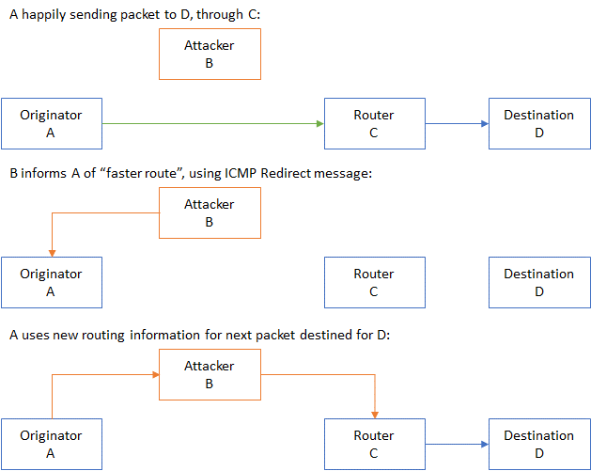

Gotta watch out for stuff like this!
Generally, hosts ignore ICMP Redirect messages
Routers pay attention to them only with security in place
Fun with ICMP!

The tracert utility makes use of the Type 11 Time Exceeded TTL Expired message
It first sends a packet with a TTL of 1 (one)
The first router decrements the TTL and responds with a Type 11 ICMP message
The utility then sends a packet with TTL of 2
This second packet makes it through the first router and then is rejected by the next router
And so on…

Try this at your cmd prompt… here’s what I got at home:

c:\> tracert www.google.com

Tracing route to www.google.com [172.217.11.164]
over a maximum of 30 hops:
1 2 ms 1 ms 1 ms Wireless_Broadband_Router.ftrdhcpuser.net [192.168.1.1]
2 7 ms 8 ms 10 ms static-50-53-32-1.bvtn.or.frontiernet.net [50.53.32.1]
3 7 ms 9 ms 8 ms 74.36.197.209
4 8 ms 8 ms 7 ms 74.40.70.45
5 19 ms 14 ms 18 ms ae2---0.cor01.bvtn.or.frontiernet.net [74.40.1.217]
6 17 ms 12 ms 14 ms ae4---0.cor01.sttl.wa.frontiernet.net [74.40.1.221]
7 16 ms 10 ms 50 ms ae0---0.cbr01.sttl.wa.frontiernet.net [74.40.5.122]
8 27 ms 26 ms 25 ms 74.40.26.131
9 25 ms 27 ms 26 ms 108.170.245.114
10 27 ms 26 ms 25 ms 209.85.248.159
11 81 ms 30 ms 32 ms 209.85.254.18
12 33 ms 32 ms 36 ms 74.125.37.136
13 33 ms 32 ms 33 ms 209.85.245.172
14 32 ms 35 ms 34 ms 108.170.247.161
15 36 ms 38 ms 35 ms 108.170.225.75
16 33 ms 33 ms 55 ms lax28s15-in-f4.1e100.net [172.217.11.164]

Trace complete.

ICMP is a protocol at which layer?

Routing Inside
ICN 9, Pg. 215-231

Routing – determining how to send an IP packet through a series of routers
Routing Domain – a set of routers/networks that are static, with known configuration
Routing Update Algorithm – used to determine best route to a destination

Distance-Vector algorithms uses a configured “cost” for specific links in a network
The cost can be based on factors like…
Bandwidth, propagation delay, ﬁnancial cost, or administrative preference

Each router determines a cost to neighboring routers and stores these in routing table
Table Entries are <Destination, Next-hop, Cost>
The costs are configured by administrators to perform “traffic engineering”

Periodically routers send a report of <destination, cost> entries to their neighbors
These can then be used to determine a total vector cost for a final destination…
by adding up the cost across all links until the final destination is reached

If a router finds that it cannot reach a neighbor, then it sets that cost to infinity

Rules for keeping routing table up to date…
Let A be a router receiving a report <D, C_{D}> from neighbor N at cost C_{N}
A can reach D via N with cost C= C_{D} + C_{N}
A updates its own table as follows:
- New Destination: Add <D, N, C> to forwarding table
- Lower Cost: Replace <D, M, C_{old}> with <D,N,C>, if C < C_{old}; M ≠ N (probably)
- Next Hop Increase: Replace <D, N, C_{old}> with <D, N, C>, where C > C_{old}

Routing Example…
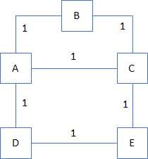
Initially, the tables for each host are…
Table | Entries
A | <B,B,1> <C,C,1> <D,D,1>
B | <A,A,1> <C,C,1>
C | <A,A,1> <B,B,1> <E,E,1>
D | <A,A,1> <E,E,1>
E | <C,C,1> <D,D,1>

When host D reports to host A, it sends <A,1> and <E,1>
A will ignore <A,1> but <E,1> is interesting!
It’s a New Destination, so add it to the table…
Table | Entries
A | <B,B,1> <C,C,1> <D,D,1> <E,D,2>
B | <A,A,1> <C,C,1>
C | <A,A,1> <B,B,1> <E,E,1>
D | <A,A,1> <E,E,1>
E | <C,C,1> <D,D,1>

Why <E,D,2>? Because A now knows how to reach E, through D, with a cost of…
(A’s known cost to D <D,D,1>) + (D’s reported cost to E <E,1>)

Next A reports to D, with <B,1> <C,1> <D,1> and <E,2>
D ignores <D,1> and <E,2>, because it already has a cost for E of 1
But <B,1> and <C,1> are new to D, so…
Initially, the tables for each host are…
Table | Entries
A | <B,B,1> <C,C,1> <D,D,1> <E,D,2>
B | <A,A,1> <C,C,1>
C | <A,A,1> <B,B,1> <E,E,1>
D | <A,A,1> <E,E,1> <B,A,2> <C,A,2>
E | <C,C,1> <D,D,1>

And if C reports to B and also E, then…
Table | Entries
A | <B,B,1> <C,C,1> <D,D,1> <E,D,2>
B | <A,A,1> <C,C,1> <E,C,2>
C | <A,A,1> <B,B,1> <E,E,1>
D | <A,A,1> <E,E,1> <B,A,2> <C,A,2>
E | <C,C,1> <D,D,1> <A,C,2> <B,C,2>

What are we missing? B and C can’t get to D!
Ok, E reports to C and then C reports to B…
Table | Entries
A | <B,B,1> <C,C,1> <D,D,1> <E,D,2>
B | <A,A,1> <C,C,1> <E,C,2> <D,C,3>
C | <A,A,1> <B,B,1> <E,E,1> <D,E,2>
D | <A,A,1> <E,E,1> <B,A,2> <C,A,2>
E | <C,C,1> <D,D,1> <A,C,2> <B,C,2>

Whew! All good, right?
Wait a minute… looking at the diagram, there’s a better route from B to D…
Currently our route table indicates B → C → E → D for a cost of 3

When A next reports to B, this will be fixed up, A will send <D,1>
And B will compare the Lower Cost <D,A,2> with existing <D,C,3> and…
Table | Entries
A | <B,B,1> <C,C,1> <D,D,1> <E,D,2>
B | <A,A,1> <C,C,1> <E,C,2> <D,A,2>
C | <A,A,1> <B,B,1> <E,E,1> <D,E,2>
D | <A,A,1> <E,E,1> <B,A,2> <C,A,2>
E | <C,C,1> <D,D,1> <A,C,2> <B,C,2>

Which represents the least total cost for each node to reach each other node.
The periodic reports eventually fills in the table and reduces the to least cost.

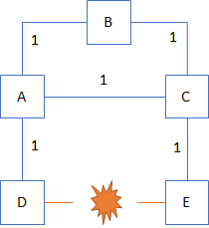
What happens when a connection breaks?
For exmaple, let’s say that the link from D to E breaks
When this happens, both D and E will update their tables…
Table | Entries
A | <B,B,1> <C,C,1> <D,D,1> <E,D,2>
B | <A,A,1> <C,C,1> <E,C,2> <D,A,2>
C | <A,A,1> <B,B,1> <E,E,1> <D,E,2>
D | <A,A,1> <E,-,∞> <B,A,2> <C,A,2>
E | <C,C,1> <D,-,∞> <A,C,2> <B,C,2>

Now, when D reports to A and E reports to C…
Table | Entries
A | <B,B,1> <C,C,1> <D,D,1> <E,D,∞>
B | <A,A,1> <C,C,1> <E,C,2> <D,A,2>
C | <A,A,1> <B,B,1> <E,E,1> <D,E,∞>
D | <A,A,1> <E,-,∞> <B,A,2> <C,A,2>
E | <C,C,1> <D,-,∞> <A,C,2> <B,C,2>

This is the Next Hop Increase case, spreading through the routing tables
Fortunately, when C next reports to A and A reports to C, we’ll be fixed up…
Table | Entries
A | <B,B,1> <C,C,1> <D,D,1> <E,C,2>
B | <A,A,1> <C,C,1> <E,C,2> <D,A,2>
C | <A,A,1> <B,B,1> <E,E,1> <D,A,2>
D | <A,A,1> <E,-,∞> <B,A,2> <C,A,2>
E | <C,C,1> <D,-,∞> <A,C,2> <B,C,2>

Note that A now has a route to E, through C, and C has a route to D, through A

Warning: Loops can form in distributed routing tables when a link breaks
The loops cause a “slow convergence to infinity” where several nodes keep reporting slightly larger costs for the missing link to each other, forever
There are techniques for overcoming these, but add complexity to the rules

Routing Outside
ICN 10, Pg. 237-263

Inside a routing domain, we can assume a coherent strategy for assigning costs to links
Between two domains, we cannot compare costs: There is no basis for comparison!

This means, if we need to decide between sending a packet through one domain or another, we can’t rely on their reported cost metrics

One way to solve this is through Hierarchical Routing…

CIDR – Classless Internet Domain Routing
Mechanism for identifying blocks of IP address

ISP – Internet Service Provider
Organization owning heirachical networks, with root providers forming backbone
Each ISP has their own routing domain
Providers service to Subscribers, which use IP addresses

IXP – Internet eXchange Point
The point at which providers connect their routing domains

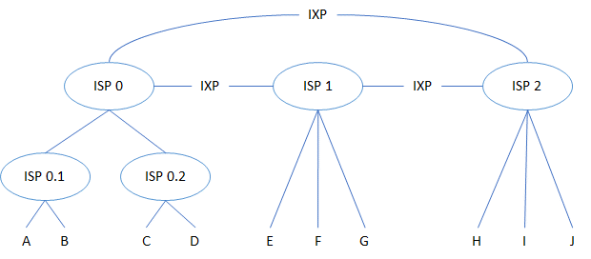

A → B Direct between A and B Within ISP 0.1’s routing domain
A → C A → ISP 0.1 → ISP 0.2 → C Within ISP 0’s routing domain
A → E A → ISP 0.1 → ISP 0 → ISP 1 → E Crosses domains at IXP

The routing tables contain entries for blocks of addresses
Each root ISP manages a large block of addresses, which can be subdivided for child ISP
Each ISP gives out IP address to it’s subscribers

Between ISPs, we need a way to route packets through other domains…

BGP – Border Gateway Protocol
Protocol for negotiating routes between independent organizations that wish to send traffic through each other to destinations on the other side

For example, if Org 1 wants to send IP packets to Org 4…

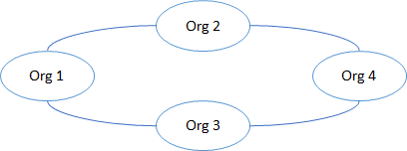

Autonomous System (AS) – An organization with its own consistent Routing Domain
BGP Speakers – Router that uses BGP
Internal BGP – Protocol for coordinating speakers within an AS
External BGP – Protocol for exchanging route information between AS
BGP Peers – Speakers in different AS, that are network neighors

Peers are configured to work with each other, they are not discovered

AS Path – The complete path of AS from one speaker to another
Because each AS has it’s own domain, the AS Path contains no cost info, just the route
Instead, BGP uses administratively defined rules for determining the “best” path
Typically that path is determined by who has paid whom for what service

Local Traffic – Packets originating and ending within an AS
Transit Traffic – Packets passing through an AS

Rules can be created for what to do with Transit Traffic at each Speaker
Again, typically this is determined by the service level purchased
Import Filtering – Applied to routes received from Peers
Best-Path Selection – Applied when choosing a route among those received from Peers
Export-Filtering – Applied when advertising routes to Peers

Ultimately, with apologies to Obi-Wan…

Hierarchical routing surrounds us, BGP penetrates us; they bind the Internet together!

